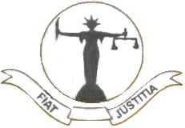
Statement issued by the Judicial Service Association of Sri Lanka.

The Supreme Court of the Democratic Socialist Republic of Sri Lanka exercising exclusive jurisdiction to interpret the Constitution vested under Article 125 of the Constitution has held that the Parliamentary Select Committee procedure which found the Chief Justice Dr. ShiraniBandaranayake guilty was unconstitutional.
The Judicial Service Association (JSA) of Sri Lanka urges all the parties concerned to respect the Supreme Court determination to avoid constitutional crisis which will ultimately lead to lawlessness in the country. The JSA also urges the Parliament to enact necessary legislation as recommended by the Supreme Court to probe alleged misbehavior of apex court Judges.
The JSA is concerned about the media campaign aimed at vilifying the judges who discharge their duties according to law and their conscience.

The Judicial Service Association of Sri Lanka
2013.01.07

President:
Adithya K. Patabendige
Vice President I
WasanthaJinadasa
Vice President II
PradeepJayathilake
Secretary
ArunaAluthge
Assistant Secretary
TikiriJayathilaka
Treasurer
R.S.S.Sapuvida
Editor
R.S.A. Dissanayaka
Assistant Editor
J. Trotsky
Web Master
R.M.A. Perera

